SETUP ENVIRONMENT :

FLASK CREATION

|  |  |
| --- | --- |
| Date | 10 Nov 2022 |
| Team ID | PNT2022TMID11845 |
| Project title | Smart fashion Recommendation Application |

**Flask install**

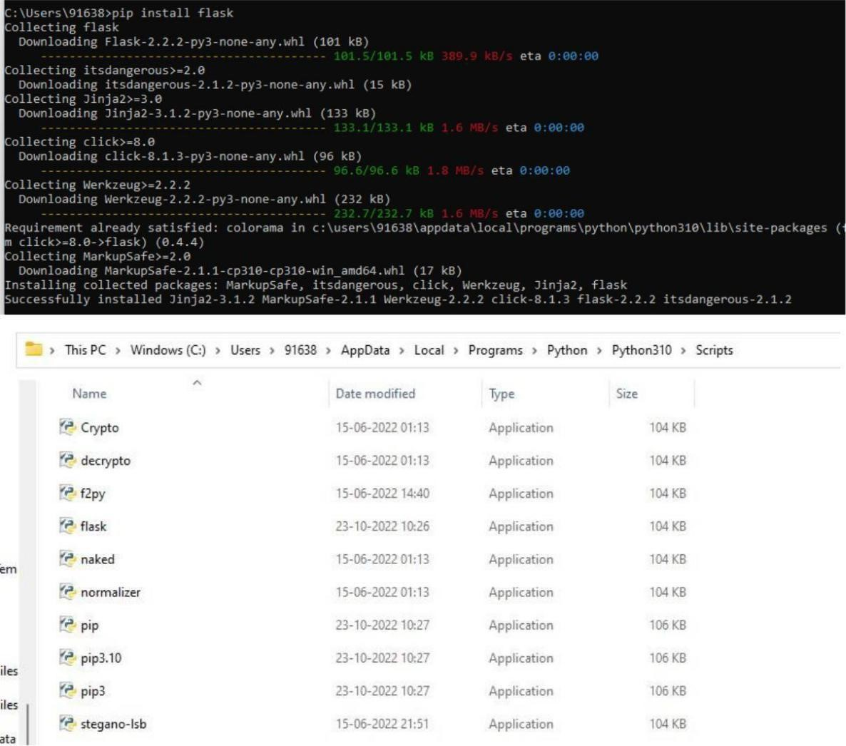

**Create flask:**

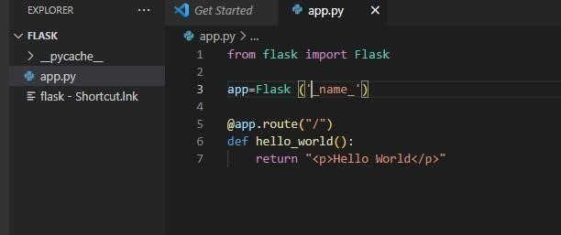

**Run flak:**

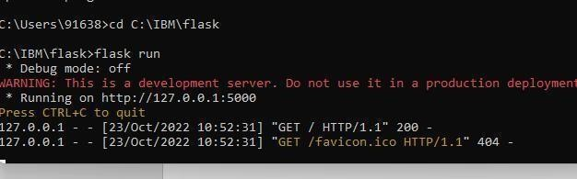

**Output**